# Using Git in IntelliJ IDEA

**Note:** To view this Google Doc as a continuous stream with no page breaks go to View and uncheck Print Layout.

## Starting a new task

Every task has its own branch that is based off of the latest version of the master branch. We must first ensure that we have checked out the master branch. The branch that is currently checked out can be seen on the right of the Version Control Bar on the bottom of the IntelliJ IDE:

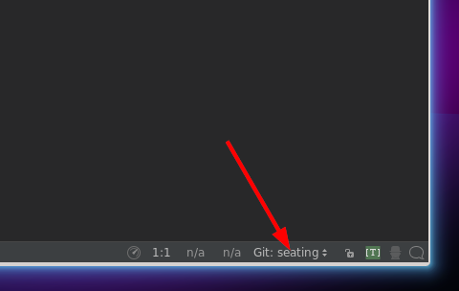

Here our current branch is called seating. To start a new task we need to switch to the master branch. This is done by clicking on the current branch to bring up the list of Git Branches. From here we can chose the branch origin/master and Checkout as new local branch.

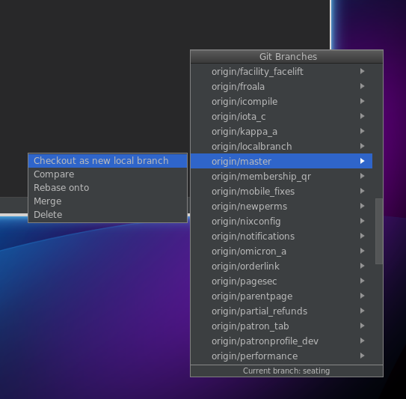

In the following dialog we can simply keep the same name. If you have checked out the master branch previously you can simply chose the local version.  
  
To ensure we have the latest changes will now pull from the master branch. This can be done from the upper bar using the VCS button with the blue arrow or by pressing Ctrl + T:

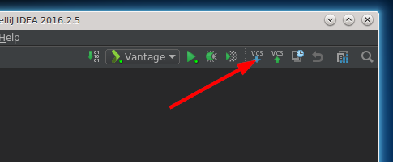

This will bring up the Update Project dialog. Leave all options as default and click OK.

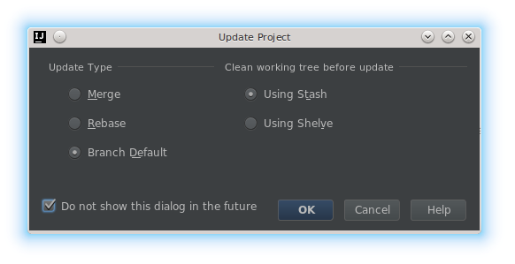

Once the pull is complete we can go ahead and create a new branch using the bottom menu again:

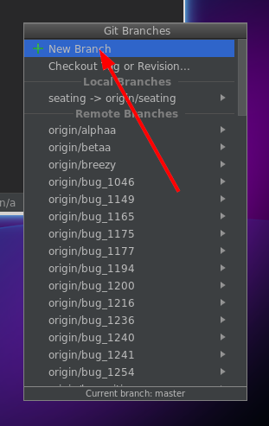

Give your branch an appropriate name and click ok. This will create the new branch locally and automatically check it out:

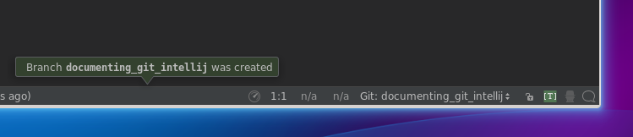

To make sure this branch is also on the repository we now need to push it up. Using the main menu, navigate to VCS > Git > Push... or use Ctrl + Shift + K to do so:

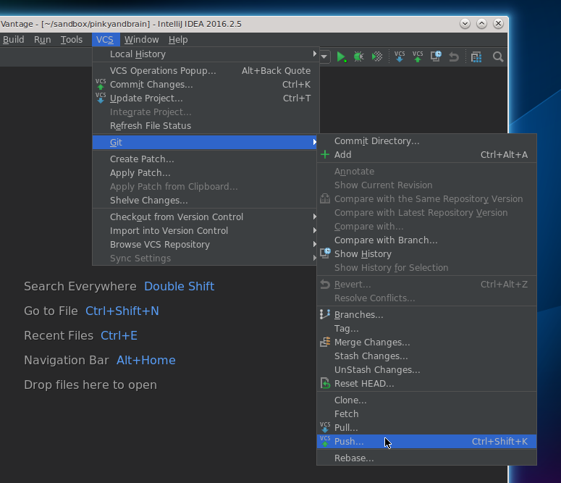

The resulting Push Commits dialog will be empty as no commits have been made. Clicking push will push your new branch to the repository:

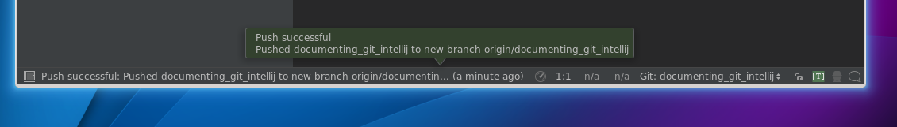

You have successfully setup a new task branch and matching remote branch to which you can commit and push your changes.

#### 

## Committing and pushing changes

After making some changes in a task branch, you can commit those changes locally to save your work. Click on the VCS button with the green arrow to show the commit dialog.  
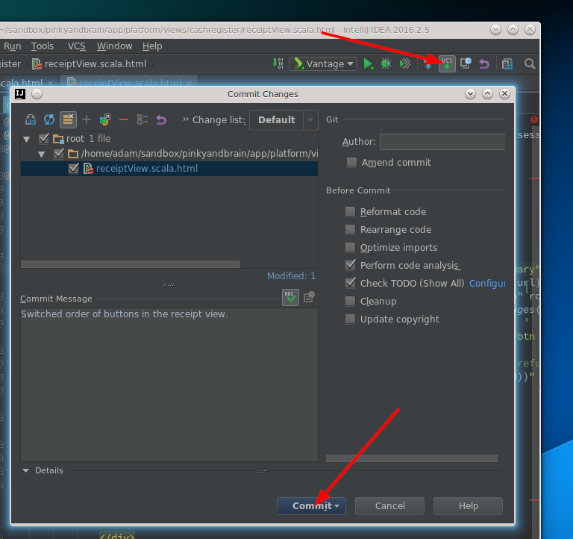

In the dialog you will see any modified files since your last commit. You can also double-click on the specific files to get a more detailed view of the changes made. Here, you can see that I modified the receiptView.scala.html file. To commit your changes locally, click Commit.

To push your changes to the repository navigate to VCS > Git > Push... or use Ctrl + Shift + K to do so:



and click Push.

## Updating your task branch

While working on a task it is a good idea to update it from time to time by pulling in the latest changes that have been made on master (rebasing from master).

To do this, we need to first checkout the master branch. Since you have already checked out the master branch before, you can chose the local branch.

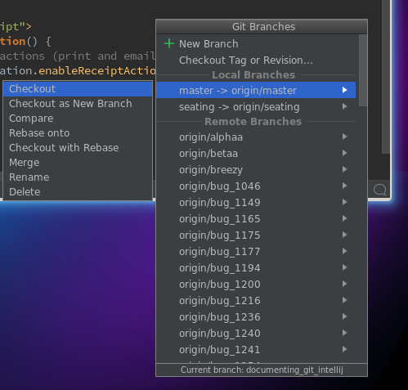

Make sure the local master branch is up to date:

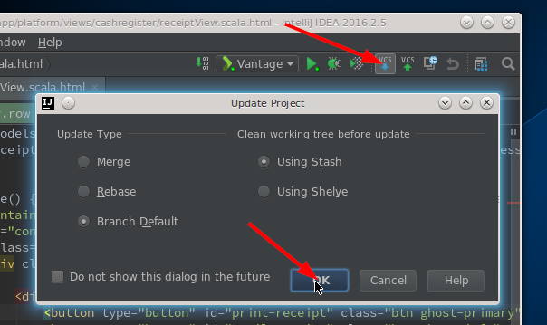

Now let’s checkout out task branch again:

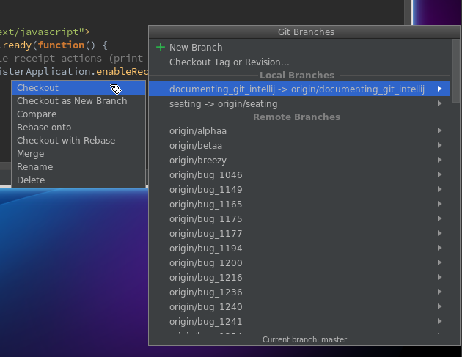

Now that we are in our task branch with an up-to-date master branch we can rebase onto master. From the same menu again select the master branch and chose Rebase onto:

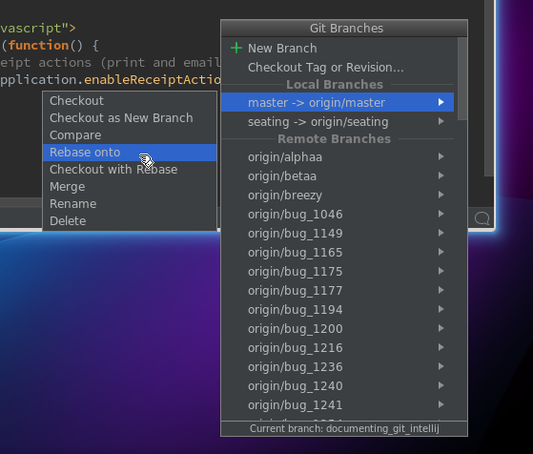

Finally, you can push your branch to the repository by navigating in the menu to VCS > Git > Push... or use Ctrl + Shift + K .

Your branch is now up to date with the master branch.